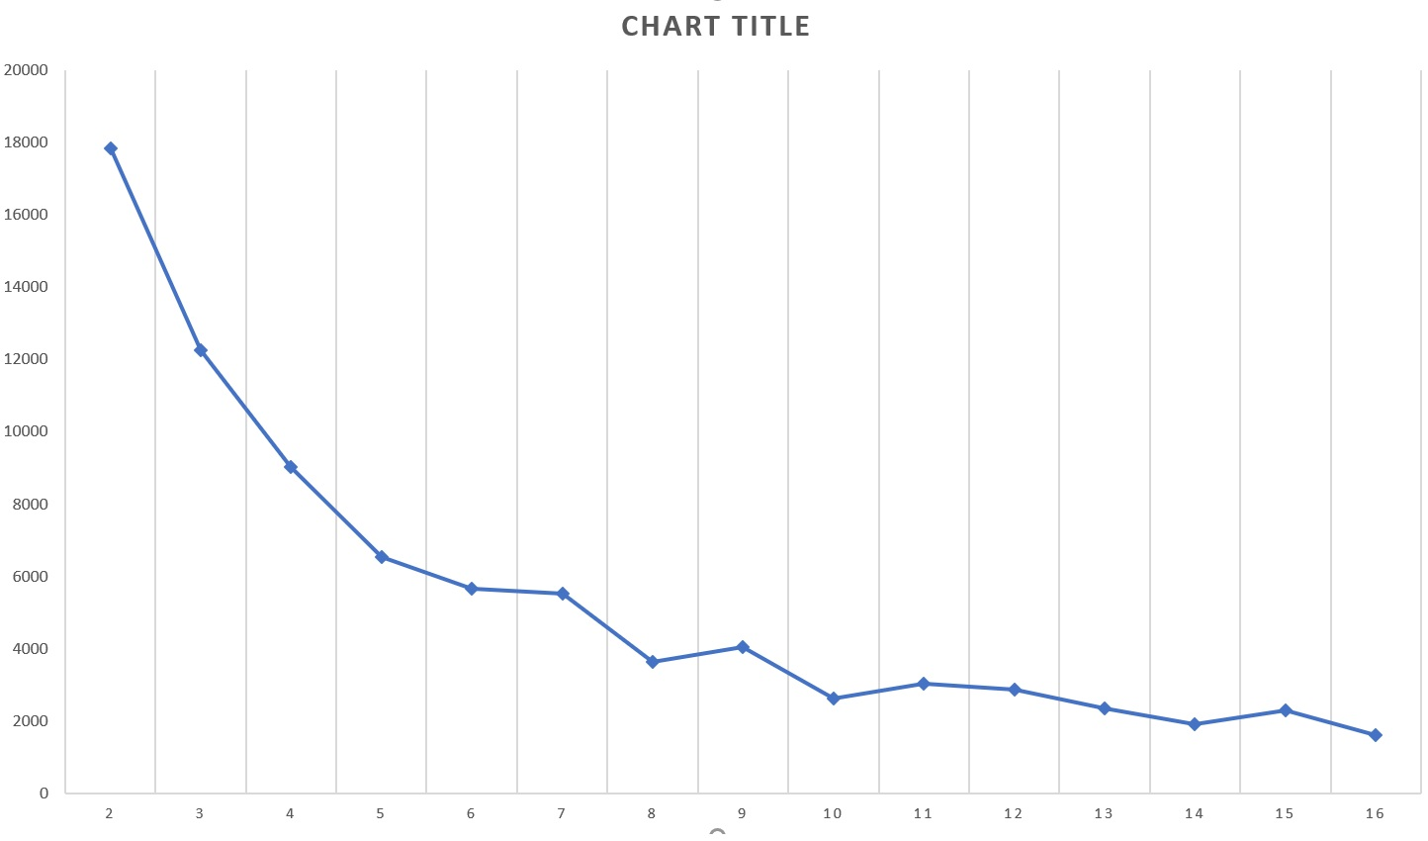

The horizontal axis indicates number of kernels(centers) and the vertical axis shows error rates.

Error rates are calculated by getting average in 100 different iterations while applying Elbow method.

This provides us to get a better result as can be seen in the figure. So we think the number of kernels(centers) that should be chosen is 6 or 8.

The csv file related to the chart is “result_elbow_distances.csv”.